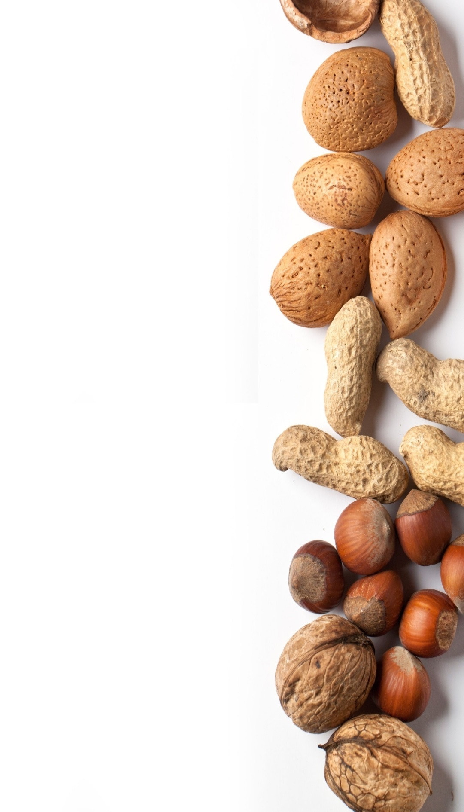
The Mixed Nuts
Christmas Set 2 Last revised on 2015.12.09

Christmas2-01-Happy Holiday(KVF).2014.12.12.pdf
Christmas2-01-Happy Holiday(KVM).2014.12.12.pdf
Christmas2-02-Winter Wonderland(KVF).2015.12.06.pdf
Christmas2-02-Winter Wonderland(KVM).2015.12.06.pdf
Christmas2-03-Silver Bells(KVF).2015.12.06.pdf
Christmas2-03-Silver Bells(KVM).2015.12.06.pdf
Christmas2-04-Santa Claus Is Coming To Town(KVF).2015.12.09.pdf
Christmas2-04-Santa Claus Is Coming To Town(KVM).2015.12.09.pdf
Christmas2-05-I Saw Mommy Kissing Santa Claus(KVF).2014.11.18.pdf
Christmas2-05-I Saw Mommy Kissing Santa Claus(KVM).2015.12.06.pdf
Christmas2-06-Most Wonderful Time Of The Year(KVF).2014.12.06.pdf
Christmas2-06-Most Wonderful Time Of The Year(KVM).2014.12.06.pdf
Christmas2-07-All I Want For Christmas Is My Two Front Teeth(KVF).2015.12.09.pdf
Christmas2-07-All I Want For Christmas Is My Two Front Teeth(KVM).2015.12.09.pdf
Christmas2-08-Caroling, Caroling(KVF).2014.01.06.pdf
Christmas2-08-Caroling, Caroling(KVM).2014.01.06.pdf
Christmas2-09-Have Yourself A Merry Little Christmas(KVF).2014.12.06.pdf
Christmas2-09-Have Yourself A Merry Little Christmas(KVM).2014.12.06.pdf
Christmas2-10-We Need A Little Christmas(KVF).2014.06.25.pdf
Christmas2-10-We Need A Little Christmas(KVM).2014.06.25.pdf
Christmas2-11-Santa, Baby(KV).2015.12.09.pdf
Christmas2-12-Up On The Housetop(KVF).2014.12.06.pdf
Christmas2-12-Up On The Housetop(KVM).2014.12.06.pdf
Christmas2-13-Mele Kalikimaka(KVF).2015.12.09.pdf
Christmas2-13-Mele Kalikimaka(KVM).2015.12.09.pdf
Christmas2-14-Jingle Bells(KVD).2015.12.09.pdf
Christmas2-15-White Christmas(KVF).2015.12.09.pdf
Christmas2-15-White Christmas(KVM).2015.12.09.pdf
Christmas2-16-It's The Holiday Season(KVF).2015.12.06.pdf
Christmas2-16-It's The Holiday Season(KVM).2015.12.06.pdf
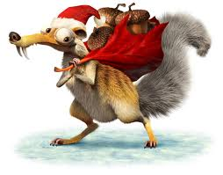
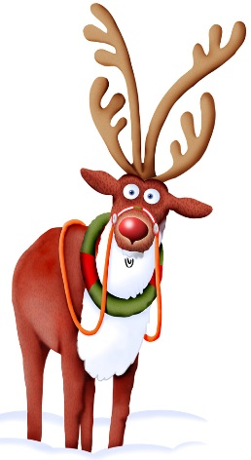
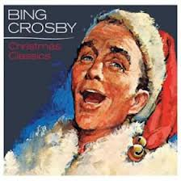
Christmas2-17-We Wish You A Merry Christmas(KVD).2015.01.01.pdf

